**A Project Report of**

**Vishwakarma Yojana: An approach towards Rurbanisation (Phase III)**

**Village: Hathidra District: Banaskantha**

****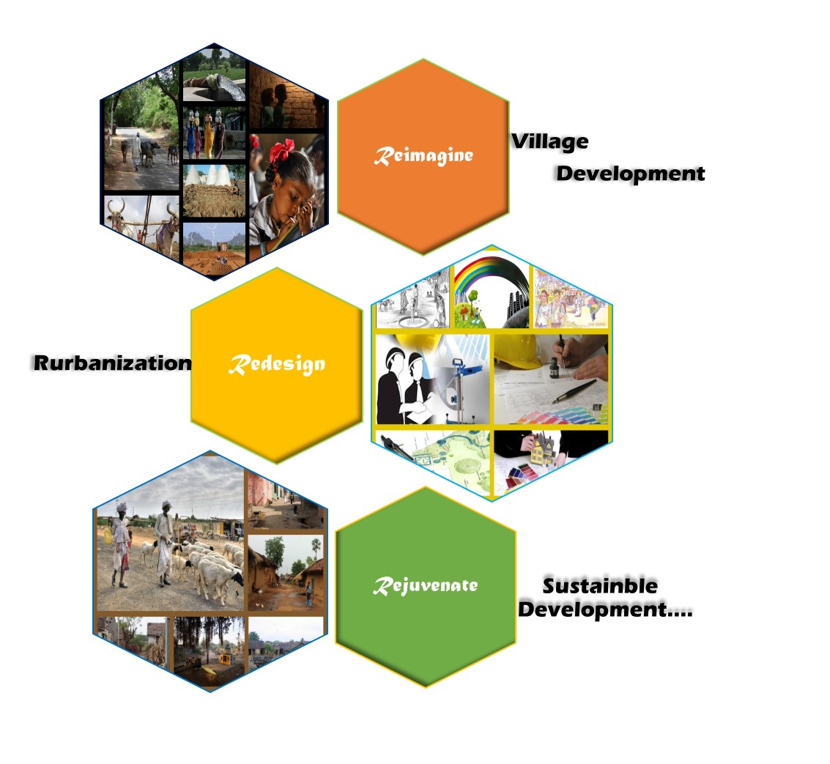

**Gujarat Technological University,**

**Ahmedabad, Gujarat**

**PROJECT REPORT**

**ON**

**“Vishwakarma Yojana: Phase-III**

**An Approach towards Rurbanisation**

**For**

**Hathidra Village, Banaskantha District, Gujarat**

**Year: 2015-16**

**Prepared by**

Name Enrollment No.

120610106034

Prajapati Vishnu

**Nodal Officers:**

Prof. K.A.Parmar

Department of Civil Engineering

Applied Department

Government Engineering College, Palanpur





**GOVERNMENT ENGINEERING COLLEGE**

**At. & Po. Jagana**

**Palanpur**

**GUJARAT TECHNOLOGICAL UNIVERSITY**

**Chandkheda, Ahmedabad – 382424**

**Gujarat**

**Abstract**

Vishwakarma Yojana is an important and prestigious project of Government of Gujarat with aim to prepare a complete roadmap of 'Rurban Development' of the village of Gujarat. It is allotted to Gujarat Technological University by the Government of Gujarat since 2012-13. The first and second phases are aimed to study the present status and techno-economic survey of undeveloped villages of the state in terms of basic and public amenities, essential commodities, and other infrastructure facilities for the need of people and to prepare report on adequacy of the available resources with reference to population of the village and growth of the area. With consultation of Local revenue authorities, TDO and DDO the future need of the village keeping to mind the need of days, future targeted population growth, growth of surrounding town or taluka places etc. a projected development plan of the village ready to execute is required to be prepared under this project as targeted outcome at end.

Hathidra is modern village which includes various basic facilities like PHC, Small scale industries, anganwadies, primary and secondary school, post office, banking facilities etc.

* 1. **Introduction of Chapter**

Gujarat Technological University is allotted important and prestigious project of Vishwakarma Yojana Phase-III by the Government of Gujarat for year 2015-16. The first and second phase projects are aimed to study the present status and techno-economic survey of undeveloped villages in terms of basic and public amenities, essential commodities and other infrastructure facilities for the need of people and to prepare report on adequacy of the available resources with reference to population of the village and growth of the area. With consultation of Local revenue authorities, TDO and DDO the future need of the village keeping to mind the need of days, future targeted population growth, growth of surrounding town or taluka places etc. a projected development plan of the village ready to execute is required to be prepared under this project as targeted outcome at end.

We have to begin the project by studying the present status and techno-economic survey of six villages in different terms of basic and public amenities, other infrastructural facilities for the need of people and to prepare a report on the expected socio-economic growth of the area. With consultation of the local revenue authorities, TDO and DDO, the leaders like the Sarpanch, the needs of the village are to be determined keeping in mind the population growth, growth of surrounding town or taluka place etc. The objective of the project is to prepare a complete roadmap of urban Development of the targeted villages. For the villages, a development plan, which is ready to execute, is required to be prepared under this project.

* 1. **Study Justification/ Need of the Study**

To provide the basic requirement and need of people in the village such as:

* Water Facilities
* Drainage Facilities
* Transportation Facilities
* Education
* Primary Health Care
* Banking Facilities
* Public Toilets
* Community hall and other amenities

For the development and progress of the village.

To reduce the migration of people from rural area to urban area.

To enhance the rural people in terms of employment, education, health etc.

* 1. **Objective of the study**
     1. Project Aim

The project is aimed to study the present status and techno-economic survey of various villages of the state in terms of basic and public amenities, essential commodities, other infrastructure facilities for the need of people and to prepare report on adequacy of the available resource with reference to population of the village and growth of the area. With consultation of Local authorities, TDO and DDO the future need of the village keeping to mind the need of days, future targeted population growth, growth of surrounding town or taluka places etc. a projected development plan of the village ready to execute is required to be prepared under this project as targeted outcome at end.

* + 1. Objective

The project is aimed to prepare a complete roadmap of Rurban Development of that village with detailed project report ready to execute. And also to collect all the report or data of human primary necessity like education, health facility, transportation services, roads, water facility (drinking, domestic use, irrigation etc.), electricity, sanitation and drainage, population, the coming plans for developing villages and standard of living of that village like how many people are below poverty line, upper-middle class, banking, telecom, post and telegraph, co-operative sectors (doodh mandali, seva sahkari, co-operative society), other public amenities like community hall, village pond, public library, solar energy.

* 1. **Methodology/ Study Frame Work**

1. Visit Hathidra village for checking status of various administration.
2. Preparing the report of lacking of various facilities in the study and doing gap analysis.
3. Preparing the plan & estimates of proposed development.
4. Suggesting the development plan in the study area village.
5. Discussing with the Nodal officer.
6. Presenting in the meeting with DDO, TDO and Sarpanch.

Figure 1.1

**2. Sustainable Planning Proposal**

**2.1 Observation**

Physical, social, sustainable infrastructures etc. are the facilities, absence of which or need of repair works we can observe by our naked eyes.

In our first visit of the Village we had visited Gram Panchayat, primary school, dairy, banks, agriculture co-operative society, anganwadies, over head tanks etc.

From which we had filled that Gram Panchayat buildings planning is so old and primary school and over head tanks are found with having small damages.

Internal streets and drainage facility is not functional. Internal roads are in very bad condition and drainage is almost open.

**2.2 Recommendation**

On the basis of our development proposer the following facilities are recommended:

* Garden
* Agriculture Centre
* Rain Water Harvesting
* Street Light
* Bio gas plant
* Internal Street should make of R.C. C.
* Community Toilet
* Community Hall
* New Efficient Drainage System

2.3 Design proposal

From above required facilities for village development, we had designed following facilities.

* + 1. Repair And Maintenance Of Bio-Gas Plant
    2. Proposals to Improve Ground Water and It’s Measures of Ground Water Discharge

**2.3.1 Biogas Plant**

Design of Biogas Plant

* This was based on technical, economic and social considerations. The size to use depends on the availability of bio-degradable materials and amount of gas required in this quantity of cow dung and the use of the gas.
* To design for the volume of plant, knowledge of gas required per day, number of cattle available, number of family members (requirement of gas for cooking and lighting), purpose and hydraulic retention time were the factors of interest. Construction time and labour resources required to build a biogas plant vary depending on several factors.
* The most important consideration is the availability of people interested in carrying out this kind of work. A biogas digester which is the apparatus used to control anaerobic decomposition was proposed to be constructed of brick masonry. This is a sealed tank or pit that holds the organic materials, and some means to collect the gas that is produced. Many different shapes and styles of biogas plants have been experimented with horizontal, vertical, cylindrical, cubic, and dome shaped.
* This project adapted the dome shape biogas plant. The bottom line is that the construction showed be simple with low demand of materials, cheap labour and low in cost and easy to build. The foundation is constructed using plain concrete slab sides.
* The slurry mix tank is also provided using masonry construction. its size is decided such that it can hold charging material for at least one day. It is fitted with a pipe which leads into the digester. The outlet chamber is constructed having an outlet pipe leading the digested slurry from the digester into the chamber where it is removed and utilized as manure. The gas is lead out from the dome to a pipe network for consumption.

Design & Dimensions Calculations:

* The number of cows per household as found on average = 7.
* The amount of dung per cow = 10 kg.
* Given the fact that the cows move far from home to graze.
* However, with zero grazing practice a dairy cow produce above 55 kg. Of dung per day.
* The amount of dung to be used for the design therefore = 100 kg. Per day.

Gas Requirement Per Day:

* Size of household = 6 persons on average.

Cooking:

* Quantity of gas required for coking per person = 0.227 m3.
* Therefore, required gas per day per household = 0.227 x 6

= 1.35 m3 of gas.

Lighting:

* Quantity of gas required for lighting per 100 candle lamps

(i.e. say 60 watts electric bulb)

= 0.125 m3 per bhp-hour.

* Assuming 3 lamps are required per household for 3 hours per day,
* Required gas per day per household

= 0.125 x 3 x 3

=1.13 m3 of gas.

Total Volume Of Gas Required:

* Old average of Gas required for cooking lighting

=1.35 m3 +1.13m3

=2.45 m3 of gas.

* Take 2.5m3 of gas for design.
* Basing on the amount of gas required per day1 kg. Of fresh dung produces 0.05m3 of biogas, this implies for 2.5m3

= 2.5 / 0.05

= 50 kg. of dung per day.

* Number of cows = 50 / 5 = 5 cows.
* This is adequate compared to house 10.

Plant Capacity:

* For the purpose of this project, the fixed dome type biogas plant was preferred. The digester volume is given by the formula:

V = v × T …………(1)

Where V = digester volume

v = volume of the fluid in the digester

T = hydraulic retention time.

But also,

V = m / ................ (2)

Where m = mass of dry input and

= density of dry material in the

fluid.

* Density of dry dung in the fluid is given by = 50 kg. /m3
* Using equation (2),
* Volume of daily slurry charge, V = mass / density

1kg of fresh cow dung

= 0.18kg of dry wet dung contains about 82 % water.

Volume of fluid,

V = 9 / 50

= 0.18m3/day.

Let hydraulic retention time be 30 days.

From equation (1), volume,

V = 0.18 x 30

= 5.4 m3.............. .(3)

Actual digester volume = 1.1 V

Actual volume of digester therefore =1.1 x 5.4

=5.94 m3

Using United Nations data for fixed dome type biogas plant, the gas production rate in tropical climate range from 0.4 to 0.5 m3/day per 1 m3 of digester volume, taking an average of 0.45 m3, 2.5 m3 gas required per day= 2.5 / 0.45 will need 5.6 m3 of digester volume .

So, 6 m3 is adequate.

Digester Dimension:

Height:

Diameter ratio = 0.9 (U.N. 1984).

H / D ratio = 0.9 D...... (4)

But,

V = 0.785 D2 H

6 = 0.785 x 0.9 D3

Dimensions:

D = 2.04m and H = 1.84m

|  |  |  |  |  |  |
| --- | --- | --- | --- | --- | --- |
| Plant Capacity (m3) | Daily Fresh Dung (kg) | Fresh Slurry | No. of Cows | No. of People | Cost (Rs.) |
| 1 | 25 | 50 | 2-3 | 3-4 | 117180 |
| 2 | 50 | 100 | 4-4 | 6-8 | 140616 |
| 3 | 75 | 150 | 6-9 | 9-12 | 175770 |
| 4 | 100 | 200 | 8-12 | 12-16 | 210924 |
| 5 | 150 | 300 | 12-18 | 18-24 | 253108 |

Table 5.2 Capacity, Daily requirements of cattle dung and biogas produced

Cost of owning and running a biogas plant per day on average is us$ 0.25, with a life of 20 to 30 years.

The initial cost may be well above the average income of the majority of the rural population.

There is need for government intervention inform of biogas loans, plastic digesters and also training of biogas technicians for construction and maintenance.

Benefits of biogas:

1) Cheap and reliable source of domestic energy.

2) Reduce foreign currency expenditures on electric appliances.

3) Methane being a green gas, its domestic use for cooking and lighting will greatly reduce its release to the atmosphere.

4) Sicknesses due to the use of firewood and charcoal will be history.

5) May encourage cattle keeping which economically will provide milk, meat and also be used for ploughing

Conclusions and Recommends:

Conclusion:

Basing on the finding of this project work, the following conclusions and recommendations have been reached:

1) The fixed dome type biogas plant was chose because of low cost and cheap technology.

2) The size of the plant digester volume was determined to be 6m3.

3) The major economic activity of the rural population in this area is cattle keeping and subsistence farming which provides disposal system for the by-products of the biogas plants in form of fertilizers.

4) The situation on the ground warrants the implementation of a biogas energy initiative as the major domestic energy for cooking and lighting.

Recommends:

1) Biogas being cheap, reliable and easy to construct can be sustainable, and such is a necessary technology which needs exploration to benefit the rural population.

2) There is need to sensitive people about the use of biogas as a cheap, reliable source of energy.

3) Government should come in to promote the use of biogas through financing of the construction at a community level or initiate the creation of biogas loans. This can be a good supplement to the ongoing rural electrification programme.

4) Need for training technicians in biogas technology as it is a new thing.

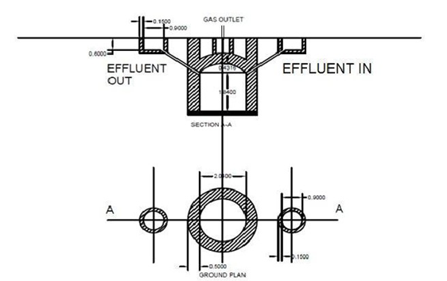

Figure 5.3 Section A-A of Bio Gas Plan

Figure 5.4 Plan for Bio Gas Plant

**2.3.2 Proposals to Improve Ground Water and It’s Measures of Ground**

**Water Discharge**

Ground water in essential source to irrigate the crop in arid regions. So if the depth of this ground water is less than the irrigation will be economical but if this depth will increase than the irrigation cost will increase by its depth.

Here in our study area average depth of water is 700 feet. This is more for the small farmers because of if they suppose to build a bore well than they will not get benefits earlier because of their small fields.

So the only way in benefits of all the farmers is to decreases the depth of this ground water.

For this we are going to suggest two methods:

1. Rain Water Harvesting of Public Building
2. Rain Water Harvesting Through Existing Tube Wells

* **Rain Water Harvesting Of Public Building**
* Scenario:

The roof top area Calculated of a School building at Hathidra for which rain water harvesting system is to be designed is around 260 m2.

Harvesting potential or Volume of water Received (m3)

= Area of Catchment (m2) X Amount of Rainfall (m) X Runoff Coefficient

* Average rainfall of last ten years = 754.8 mm

Taking Runoff Co-efficient for the proposed roof-top = 1.0

Hence,

Total volume of surface runoff water suppose to be collected

= 260 x 0.754 x 1 = 196.04 m3/year

* Design for Optimum Dimensions Of The Tank:

Size of the tank = Total quantity of water collected in one year + Take 20% of that

Extra for future variations in storage

= 196.04 + (0.2 x 196.04)

= 235.248 m3

Taking height of tank = 1.8 m

So, Area of base =235.248 / 1.8 = 130.69 m2

Let’s take square base having each of that side = B m

(Or rectangular base may also be considered as per land availability).

Hence,

Size of each side of the base = (130.69)1/2 = 11.43 m ≈ say 12.0 m.

So our tank will have dimensions as 1.8 m X 12.0 m X 12.0 m (taking square tank)

This is not economical.

As water is stored on monthly basis, Size of the tank will be equal to the excess amount of water left over after consumption. Hence, mostly excess amount of water assumed to be collected during the period of maximum rainfall i.e. in months of June, July and August.

Assuming amount of water consumed per month

= 100 nos. of student X 0.05 m3/day water demand X 30 days

= 150 m3

Hence,

Total amount of water to be stored

= Size of tank

= (235.248 - 150) m3

= 85.248 m3

Now, fixing the height of tank as 1.8 m.

Thus,

Area of the base = 85.248 /1.8

= 47.36 m2

And, size of each side of the base = (47.36)1/2 = 6.88 m ≈ say 7.0 m.

So, as per suitability base can be taken as square of size 6.5 m x 6.5 m

(Or rectangular as accordingly).

Hence, now tank will be of dimension 1.8 m X 6.5 m X 6.5 m which is

Economical and feasible.

Thus this is the optimum dimension of the tank.

* **Rain Water Harvesting Through Existing Tube Wells**

In areas where the shallow aquifers have dried up and existing tube wells are tapping deeper aquifers, rain water harvesting through existing tube wells can be adopted to recharge the deeper aquifers.

* Features
* 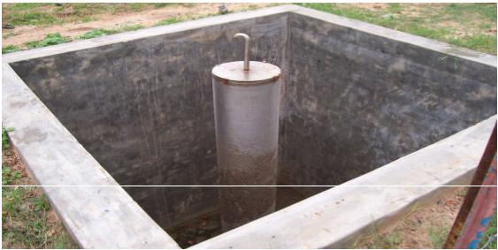Fast method of recharge.
* Excellent process for the replacement of the over exploited aquifers. Exploited aquifers.
* Boon for the areas were surface runoff cannot penetrate underground due to low permeable upper layers.
* Quality of groundwater improves.
* Replacing the top casing pipe of the tube/bore well with a dual V-wire screen (0.5mminside0.75mm outside) filled with coarse sand as filter media.
* 3m x3m x 3m pit is excavated around the casing pipe of the tube well to accommodate run off. The pit also acts as a settling pit and water also acts as a settling pit and water passes through the verticals and filter.
* Chemical or biological pollution should be avoided, as it may deteriorate the deeper aquifers.
* Proper provision for regular maintenance is required.

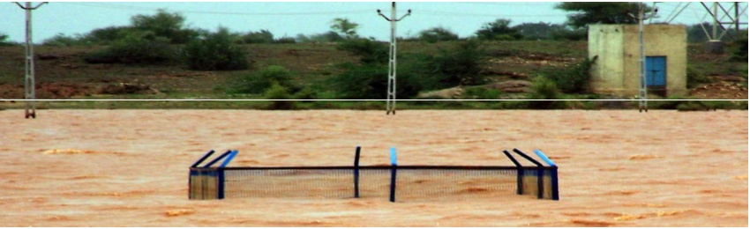

In the study area we can provide such system in ponds and surrounding area of ponds which is gets water logged during heavy rains.

For one new tube well it total cost can be calculated as follows:

Cost of drilling of 700 feet: (900)110= Rs. 77000/-

Cost of casing (We will provide only 490 feet casing because below it

hard strata are available which don’t needs casing)

(7 inch dia., 2.5mm thick, 6kg per cm2 strength): (490) 320= Rs. 1,56,800/-

Cost of welding of casing: (490)110= Rs. 53,900/-

Finishing cost: Rs. 7000/-

Total cost: Rs. 2,94,700/-

As per topography need of total tube well is four.

So total cost for this system is 11,78,800/-

Expected outcome:

According to rain fall data average rain fall in study area is 754.8 mm in 2886.3 hector area (28863000 m2). So annual income in village is 2,17,85,792.4 m3.

Assume efficiency 50% because percolation and evaporation effects.

So annual water going into ground through tube well is 1,08,92,896.2 m3.

Although this method is not economical but according to its advantages it may be implemented.

* **Conclusion**

The conclusion from all over studies is as follow:

* The village study enabled us in studying the various aspects of the village life.
* We came to know various things knowing which perhaps were not possible without visiting the village among the rural population.
* Our visit helped us to understand the lives of the villager, their need and various dynamics relating to it.
* The First hand experience is how they sustain their livelihood, which kind of difficulties they face for livelihood and other expenses of household.
* We also saw the various development plans running in the village and impact of it helped us to sharpen our understanding of these plans and ground realities associated with them.
* The facts like equality between different castes, female position in the house, unity among villagers etc are among some of the positive aspects of the village. Still there is sufficient scope of improvements in the village related to the providing of livelihood opportunity to the villagers.
* We can say that providing subsidies will not help but what the villagers actually needed is the information and knowledge about their products, their value and their demand in the outside market, so that they could get appropriate return for their hard work.
* And the second hand experience is how they cope up with the expenditure when they have no job.
* It’s easy to stay outside the village and suggests various means for the development of village but the real picture is quite different in the village.
* The village do have its bright colour which is absent in urban areas, even in many developed cities of the country.
* Abstract of Data

We are so greatful of GTU that they had created such a useful programm by we students can get real touch of our encient indian culture. From an expiernce which we had got under this programm from that we have strong belief to utilise our maximum skill in planning and rearranging the whole system according the data we had collected in our visit of our allocated village. It has opened up the curtains from our eyes to watch the rural world as a most essential part of the development process.

According to which the village needs some replanning and repair works. We had here suggested some design proposal under given guidelines.